Name: Muhammad Uzair

Roll No. L1F18BSCS0311

Section - H

Database

Lab 11

Task 1

select concat(first_name,' ',last_name) as Full_Name,

(select count(customer_id) from orders where orders.customer_id = customers.id and payment_type = 'Cash') as total_order_count

from customers

group by (id)

having total_order_count > 0;

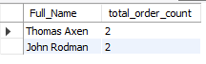

Task 2

select id, order_date, (select status_name from orders_status where orders_status.id = status_id) as stats

from orders where exists

(select count(order_details.order_id) as different

from order_details

where orders.id = order_id

having different >= 3);

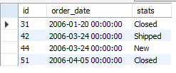

Task 3

select concat(first_name,' ',last_name) as Employee_Name

from employees where id IN

(select employee_id from employee_privileges

where privilege_id IN

(select id from privileges where privilege_name = 'Purchase Approvals'))

and employees.city = 'Redmond' or employees.city = 'Bellevue' or employees.city = 'kirkland';

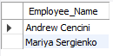

Task 4

select s1.city, count(s2.city) as Total_Suppliers

from suppliers as s1

inner join suppliers as s2

on s1.city = s2.city

group by s2.city;

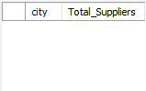

Task 5

select product_name, sum(unit_cost) as Amount

from products

inner join purchase_order_details

on products.id = product_id

group by(product_id);

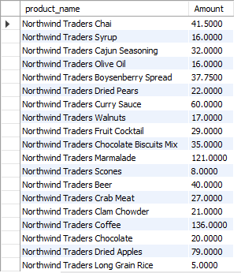

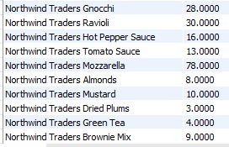

Task 6

select category, max(list_price), min(list_price), avg(list_price), sum(list_price)

from products

group by category;

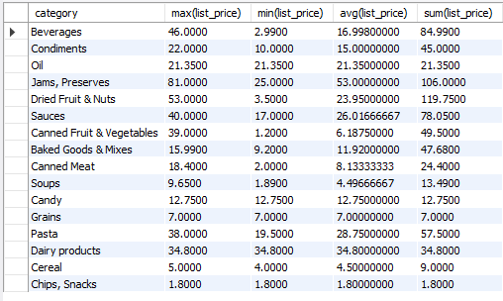

Task 7

select concat(first_name,' ',last_name) as Fullname

from employees

inner join orders

on employees.id = orders.employee_id

group by(orders.employee_id)

having count(employee_id) = (select count(employee_id)

from orders

inner join employees

on employees.id = orders.employee_id

group by(orders.employee_id)

order by count(employee_id) desc limit 1);

